README2 (Software Operation Instructions)
Before using the software, please ensure that file ‘random_forest_diabetes_model.joblib’ exists in the file folder. You can also change other training model. However, this means that you need to modify the code of the interactive interface, and at the same time, ensure that the model that has been trained and is ready is saved in the same folder. If the model training is missing, you can click on the corresponding algorithm and run it. In this way, the trained model will be automatically saved in the same folder.
This system is based on Python language to realize the function deployment and prototyping of the interactive interface. The following figure shows the workflow diagram of the interactive system.
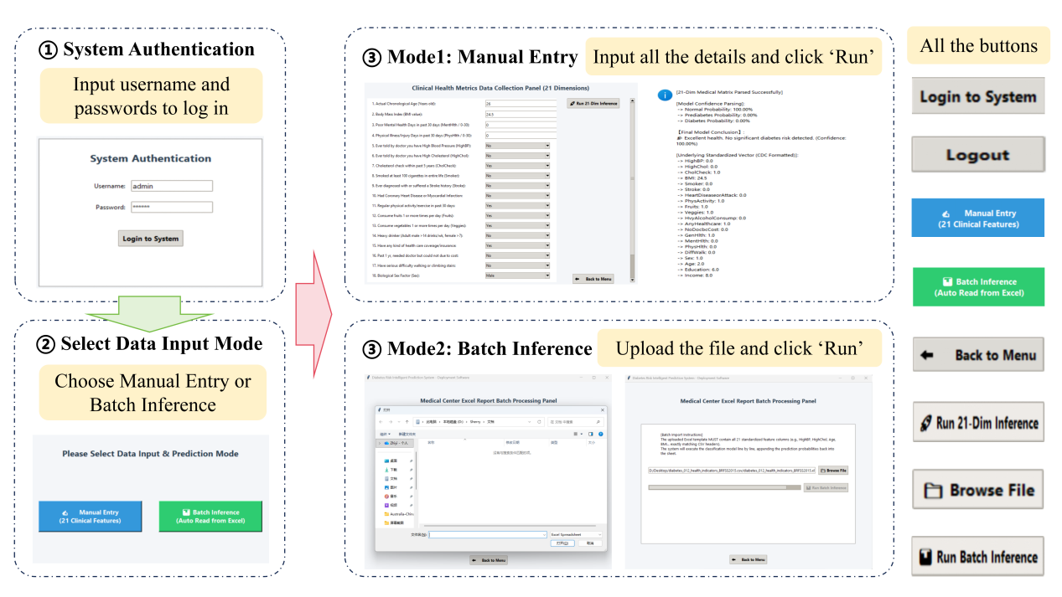
When you open the software, you will be taken to the user login screen. Users need to enter their account number and password correctly to log into the system. If the password is entered incorrectly, the software will give an error message. The interactive login screen is shown in the figure. The default account is "admin" and the password is "123456".
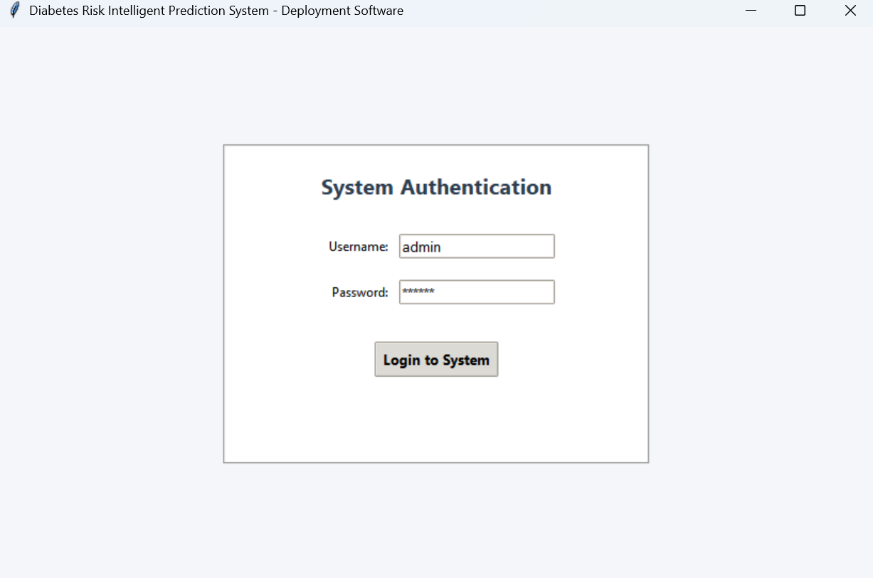
After logging in, users will be given the options of “manual entry” and “batch inference”. Users can click on the appropriate button to screen according to their needs. If the user has completed all the operations, he/she can click “logout” to exit the account and return to the login interface. The interactive interface is shown in the figure.
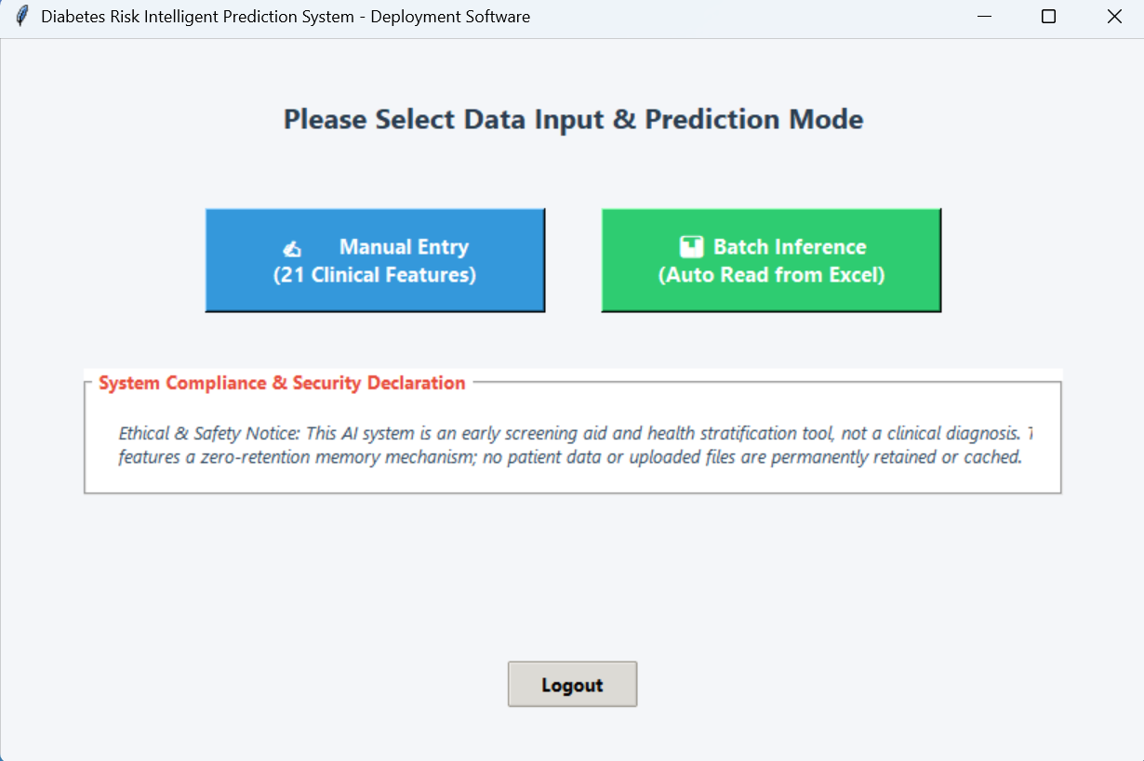
If the user selects “manual entry”, the user is redirected to a screen where the probability of disease is predicted by manual entry. The interface consists of 21 questions that translate the indicators collected in the questionnaire into easy-to-understand questions. For dichotomous qualitative characteristics, the interface enforces the use of drop-down radio boxes and strictly limits the options to “Yes” and “No”. This design prevents arbitrary blind typing by the user from the front end and ensures the structural integrity of the underlying data. For continuous quantitative features, the interface provides standard text input boxes and is equipped with an error blocking mechanism in the background. Once the user enters illegal or non-numeric characters, the system will automatically smooth and correct them to standard clinical default values, effectively reducing the risk of program crash. After the user enters all the indicator values, click the “Run” button to get the results. Since the software pulls in pre-trained models, it is able to give predictions within a few seconds. Once the prediction is complete, the relevant result data is displayed in the form of a pop-up window. The pop-up window will show the judgment of the risk of diabetes and give the confidence interval. The pop-up window also displays the input values for all indicators for the user to check. If the user completes the self-assessment, they can click the back button to return to the previous screen. The interactive interface and results pop-up window are shown below.
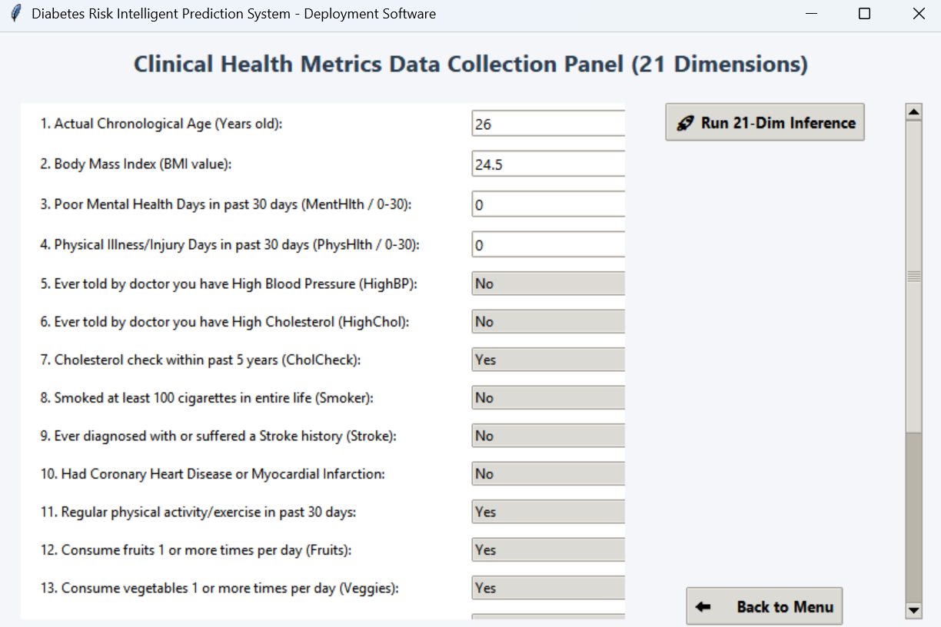
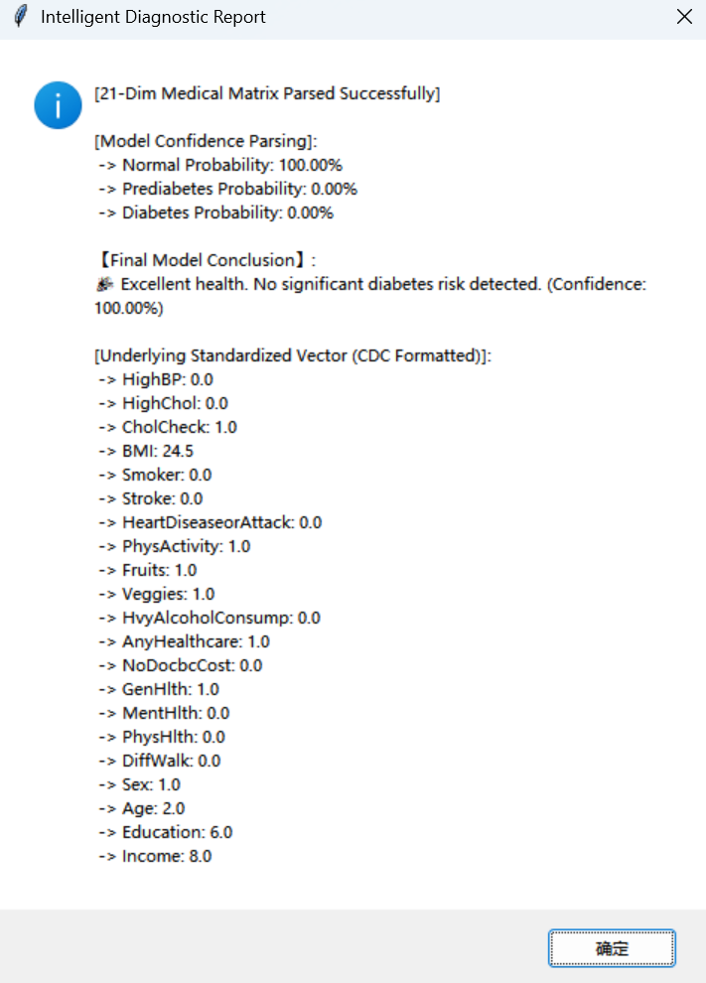
If you select “Batch Inference”, you will be redirected to the interface of batch disease probability prediction by file import. The interface can directly import excel files for prediction. The interface seamlessly calls the native file dialog of the operating system. Users can select the source data table in an intuitive browsing experience. Once the forecast is complete, the data table is saved in the destination folder. The user can also return to the previous screen by using the exit button. The interface and some of the prediction results are shown below.
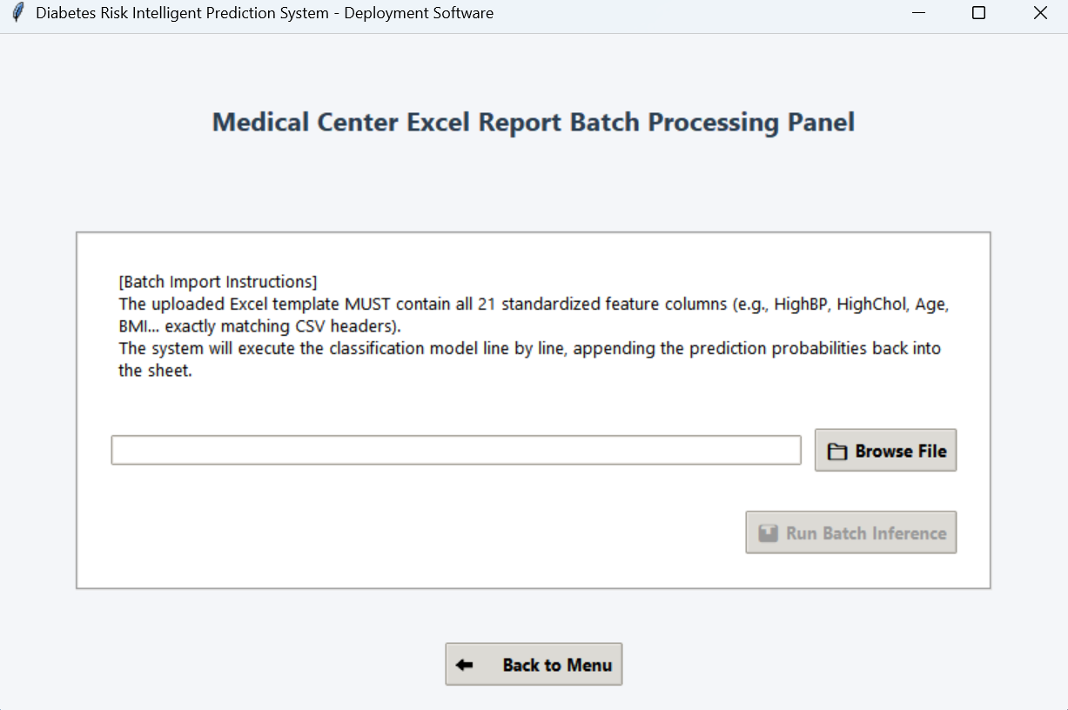
HighBP | … | Income | Result | Normal (%) | Prediabetes (%) | Diabetes (%) | Confidence (%)
1 |  | 3 | 0 | 78 | 0 | 22 | 78
0 |  | 1 | 0 | 99 | 0 | 1 | 99
1 |  | 8 | 0 | 80 | 3 | 17 | 80
1 |  | 6 | 0 | 87 | 2 | 11 | 87
1 |  | 4 | 0 | 92 | 1 | 7 | 92
This AI system realizes full-featured deployment and prototyping of interactive interfaces through Python language. In order to guarantee an industrial-grade medical software experience, the front-end of the system is deeply integrated with an asynchronous multi-threaded architecture. The design successfully realizes the complete separation of the interface control flow from the back-end computation flow. As a result, when the system performs batch reasoning on tens of thousands of data, the front-end UI still responds smoothly without system jamming or unresponsiveness. The front-end interactive interface adopts a highly structured, wizard-style form layout. The interface is designed with strongly constrained control components for different types of data to reduce manual entry bias and improve the quality of prototype delivery.

